**HTML FRAMES**

* With frames, you can display more than one HTML document in the

same browser window.

* Each HTML document is called a frame

The Frameset Tag

* + The <frameset> tag defines how to divide the window into frames
  + Each frameset defines a set of rows or columns
  + The values of the rows/columns indicate the amount of screen area each row/column will occupy

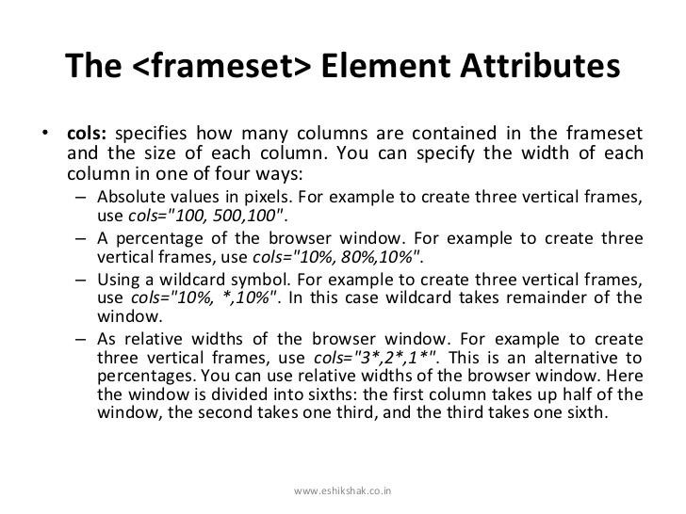

# **Frameset attributes**

* Rows
* Border- Specifies frame border
* Framespacing- specifies the amout of space between frames in frameset in pixels

# **Frame attributes**

* Src- Indicates the file that will be loaded in the frame
* Name- allows to specify the name.
* Scrolling- specifies the need of a scroll bar with value “yes” or “no”.
* Frames.html

**VERTICAL & HORIZONTAL FRAMESET**

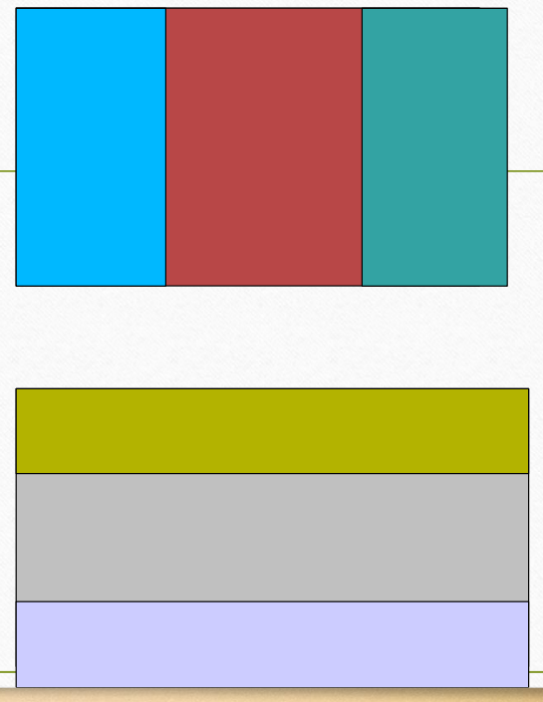<html>

<frameset cols="30%,40%,30%">

<frame src="frame_a.htm">

<frame src="frame_b.htm">

<frame src="frame_c.htm">

</frameset>

</html>

<html>

<frameset rows="30%,40%,30>

<frame src="frame_a.htm">

<frame src="frame_b.htm">

<frame src="frame_c.htm">

</frameset>

</html>

# **XHTML**

Here are the important points to remember while writing a new XHTML document or converting existing

HTML document into XHTML document

* + Write a DOCTYPE declaration at the start of the XHTML document.
  + Write all XHTML tags and attributes in lower case only.
  + Close all XHTML tags properly.
  + Nest all the tags properly.
  + Quote all the attribute values.
  + Forbid Attribute minimization.
  + Replace the **name** attribute with the **id** attribute.
  + Deprecate the **language** attribute of the script tag.

<img src="/images/xhtml.gif" width=250 height=50 />

<img src="/images/xhtml.gif" width="250" height="50" />

<img src="/images/xhtml.gif" name="xhtml_logo" />